**LEBANESE AMERICAN UNIVERSITY**

**USAID – HIGHER EDUCATION SCHOLARSHIP PROGRAM**

**HES - Volunteering Program Verification Form**

This form is to be used to document volunteering hours. If a student volunteers for multiple organizations, a separate form must be used for each organization. **This form must be turned in by the 28th of each month, the latest.**

I certify that the scholar Alaa Al Ibrahim completed a total of 5 hours of service at InnovaThrive.

The hours were completed hours as per the below:

Hours # 0 (date) _2/12 – 6/12_ (initials of supervisor) __A.K.___

Hours # 0 (date) _9/12 – 13/12_ (initials of supervisor) __A.K.___

Hours # 5 date) _16/12 – 20/12 (initials of supervisor) __A.K.___

Hours # 0 date) _23/12 - 27/12 (initials of supervisor) __A.K.___

Brief description of the activities the scholar performed or participated in:

Research about AI in Combating Cyberbullying on social Media platforms   
Definition, advantages, disadvantages, challenges, future research

Written feedback about the scholar’s performance:

Alaa Al Ibrahim’s research on AI in combating cyberbullying on social media platforms was well-conceived and comprehensive. Despite this, the volunteering form was submitted late, which is unacceptable. Future submissions must adhere strictly to deadlines to ensure smooth operations and avoid further issues.

Please rate the overall performance of the scholar at your organization:

|  |  |  |  |
| --- | --- | --- | --- |
|  | Mastery (5) | Proficient (3) | Emerging (1) |
| **Problem solver** | X |  |  |
| **Engaged & Committed** | X |  |  |
| **Open-minded & multicultural** | X |  |  |

Signature

& stamp

__________________________

_

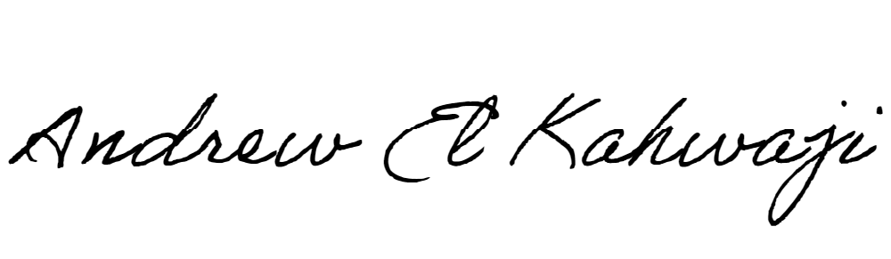

Printed Name _Andrew El Kahwaji_

Date __26/12/2024___

Email __andrew.lifesculptor.coo@gmail.com __

Phone __+961 71 914 378__